### Fruit Finder

Ethan Russell, Scott Cai

Rose-Hulman Institute of Technology

CSSE-463 Image Recognition

Email: [russelec@rose-hulman.edu](mailto:russelec@rose-hulman.edu), [cais1@rose-hulman.edu](mailto:cais1@rose-hulman.edu)

#### Abstract

Simple images can be classified using thresholds of color and post processing. We developed an algorithm to find specific fruit within pictures containing mixed fruit on relatively simple backgrounds. This algorithm characterizes the pixels based on hue, saturation, and value thresholds set through quantitative analysis and adjustment. Then, the algorithm rejects some clusters of pixels that are too small to be fruit, and performs morphological operations to smooth the fruit shapes. The algorithm performs very well on images with a clear background and fruit that do not overlap. It achieves 98.3% accuracy for identifying fruit across three test images. However, the algorithm degrades when there is excessive overlap of fruit; it cannot distinguish neighboring fruit.

**1. Introduction**

We have written an algorithm to find and count different types of fruit within color images. Specifically, the fruit we focused on are apples (only red), oranges, and bananas. This may seem trivial – a simple color filter to separate red, orange, and yellow should suffice. However, this is not nearly so simple. The fruits vary in color and shading enough that there is significant overlap in the colors. For example, an orange with an under-ripe portion may look quite yellow, like a banana. On the other hand, an apple that is too dark and in the shade may not even look like a fruit to that algorithm. We have created an algorithm that can find most fruits accurately under various circumstances. For our algorithm to function as intended the image must have a background that does not match the fruit color. Our algorithm can accommodate a wide array of lighting conditions, but it struggles to identify multiple fruit of the same type that are touching.

**2. PREpROCESSing**

The first step of our fruit finder is to filter based on the pixel color characteristics. To establish metrics to for the filter, we needed to do quantitative analysis of the colors of the fruit. We started by examining the RGB color values of each of the fruit using photos taken under daylight and fluorescent lighting conditions. We found that RGB would be very difficult to come up with reliable metrics. For example, to define a color range for apples, there would need to be a range of red values, a different range of green values, and yet another range of blue values. These ranges would define a 3D “cube” of color that encompasses many colors, not all of which would be red. Coming up with RGB ranges in this way would yield too wide of a range of colors and would not be appropriate for separating fruit. Instead of using the RGB color space, we chose to use HSV for our color filtering. This would give us a single range for the hue, then separate ranges for saturation and value. This would be much easier to specify the colors of our fruit. We started by converting the images to HSV using MATLAB’s built-in rgb2hsv function. We plotted hue, saturation, and value histograms of daylight and fluorescent images for each fruit.

**2.1 Apples**

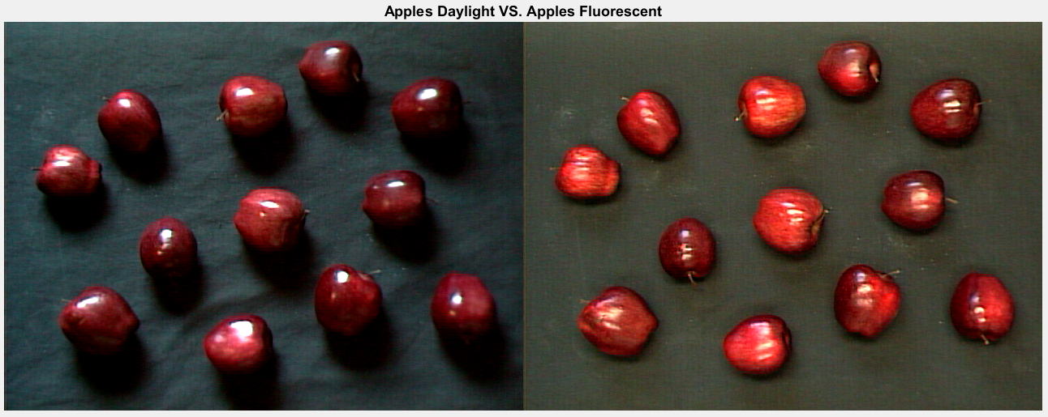

*Figure 1: This compares the images for apples in the daylight (left plot) and in fluorescent light (right plot)*



*Figure 2: This shows the histogram of the hue values for 'apples_day.tiff' (top plot) and ‘apples_fluor.tiff’ (bottom plot)*

Since we know the apples are red, we are only interested in the hues from 0 to 0.1, and from 0.9 to 1, roughly. This matches our apple hue histogram in Figure 2, where there are peaks at 0 and 1. We can assume that anything outside that range is not an apple, and therefore can be ignored for our apple filter. For the histograms for the saturation and value, we will only examine the saturation and value data corresponding to hues < 0.1 or > 0.9.



*Figure 3: This shows the histogram of the saturations after applying the rough hue filter for 'apples_day.tiff' (top plot) and ‘apples_fluor.tiff’ (bottom plot)*

From Figure 2, we can see that the saturation depends largely on the lighting. However, in both histograms, there are more saturation values between 0.5 and 1. We speculate that saturations below this value may be background pixels that were not removed by our preliminary filter. We will move on to use a saturation cutoff of 0.5 for our initial filter design.



*Figure 4: This shows the histogram of the values after applying the rough hue filter for 'apples_day.tiff' (top plot) and ‘apples_fluor.tiff’ (bottom plot)*

From Figure 3, we can gather that for apples, the value is greatly dependent on the lighting of the picture, so we must accommodate a wide range of values with our filter. From these graphs, we chose to accept values greater than or equal to 0.05. Also examining the photos of the apples in Figure 1, we can see the apples can get very dark, which supports the decision to set a relatively low value cutoff for apples.

**2.2 Bananas**

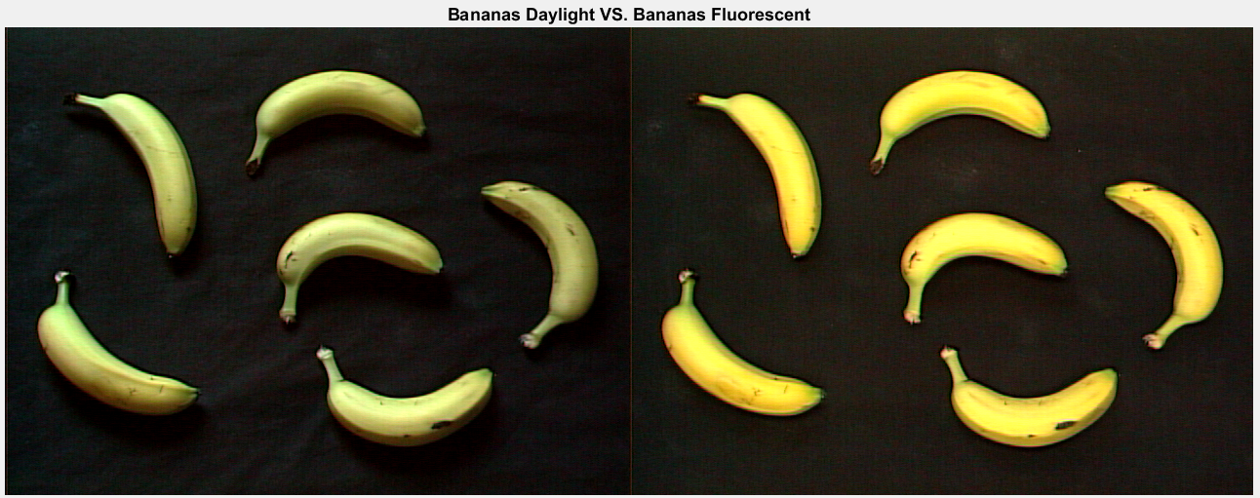

*Figure 5: This compares the images for bananas in the daylight (left plot) and in fluorescent light (right plot)*



*Figure 6: This shows the histogram of the hue values for 'bananas_day.tiff' (top plot) and ‘bananas_fluor.tiff’ (bottom plot)*

From Figure 6, we can interpret that the banana’s hues are not very distinct from the background image. We can estimate the hue of the bananas is between 0.1 to 0.3, because that is the general range for yellow. For the saturation and value histograms, we will only examine pixels with hue between 0.1 and 0.3.



*Figure 7: This shows the histogram of the saturations after applying the rough hue filter for 'bananas_day.tiff' (top plot) and ‘bananas_fluor.tiff’ (bottom plot)*

From Figure 7, we can tell that these pixels follow a fairly normal distribution for saturation. We can choose an initial saturation cutoff of 0.4.



*Figure 8: This shows the histogram of the values after applying the rough hue filter for 'bananas_day.tiff' (top plot) and ‘bananas_fluor.tiff’ (bottom plot)*

From Figure 8, we can see there is a large peak in value at roughly 0.1. We can assume that this peak is caused by background pixels, because the bananas are much lighter in color than the background. We wish to reject this background peak, so we chose an initial value cutoff of 0.25.

**2.3 Oranges**

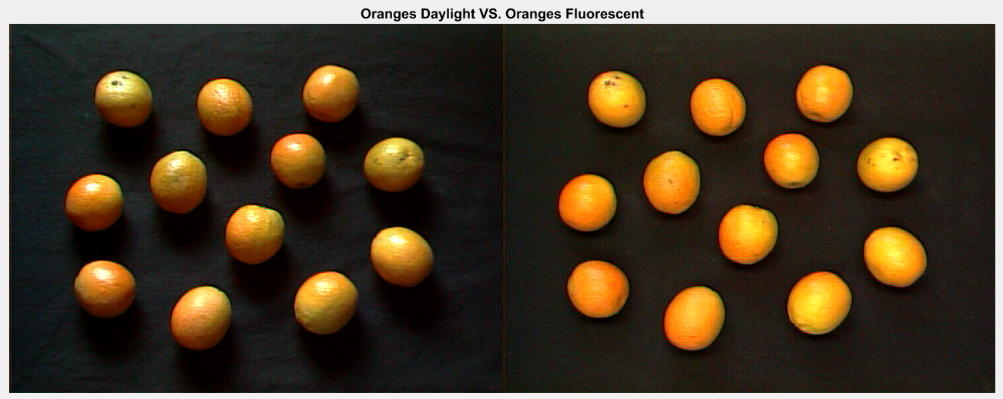

*Figure 9: This compares the images for oranges in the daylight (left plot) and in fluorescent light (right plot)*



*Figure 10: This shows the histogram of the hue values for 'oranges_day.tiff' (top plot) and ‘oranges_fluor.tiff’ (bottom plot)*

From Figure 10, we can see that there is a peak in hue from 0 to 0.15, which corresponds roughly with the color orange. We will filter based on this range of hues. The histograms for saturation and value only examine pixels with hues in that range.



*Figure 11: This shows the histogram of the saturations after applying the rough hue filter for 'oranges_day.tiff' (top plot) and ‘oranges_fluor.tiff’ (bottom plot)*

From Figure 11 we can see that the saturation has a peak from 0.7 to 1. There is also a raised section from 0.3 to 0.5, but this is fairly low saturation and could be due to the background pixels which were not filtered out by the preliminary filter. We will choose an initial saturation cutoff of 0.5 for the oranges.



*Figure 12: This shows the histogram of the values after applying the rough hue filter for 'oranges_day.tiff' (top plot) and ‘oranges_fluor.tiff’ (bottom plot)*

Finally, Figure 12 shows a large peak in value between 0 and 0.2, which may be attributed to the background pixels which were not removed by the preliminary filter. We will choose an initial lower value limit of 0.3 in attempt to reject background pixels.

**3. HSV Filters**

After collecting and analyzing the HSV histograms for the fruit, we created a filter based on the rough values we found. This initial filter can be found in table 1.

*Table 1: This shows the thresholds we define for the initial fruit HSV filter*

|  |  |  |  |
| --- | --- | --- | --- |
|  | **Hue** | **Saturation** | **Value** |
| **Apple** | H<=0.1 or H>=0.9 | S>=0.5 | V>=0.05 |
| **Orange** | 0<=H<=0.15 | S>=0.5 | V>=0.3 |
| **Banana** | 0.1<=H<=0.3 | S>=0.4 | V>=0.25 |

Using the initial threshold values in Table 1, we created a filter that would determine whether each pixel would pass the threshold for each fruit. We created an RGB mask to specify where the output of this filter. Red pixels correspond with apples, green pixels correspond with oranges, and blue pixels correspond with bananas. The RGB mask also shows where the filter identified multiple types of fruit. For example, many of the bananas are cyan, meaning they are both blue and green. The filter identified the banana to be both a banana and an orange.

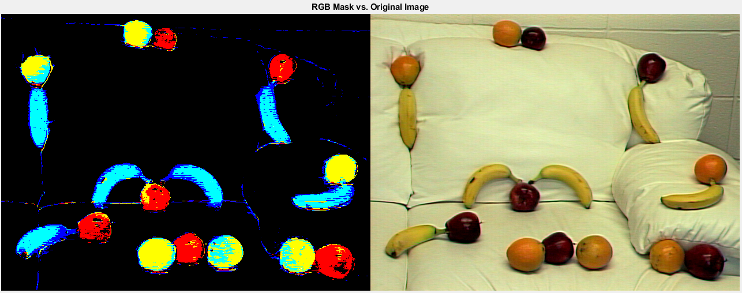

*Figure 13: Left: RGB mask using the initial filter values in Table 1. Right: original image, mixed_fruit2.tiff. See additional images and masks in Appendix A.*

From Figure 13, it is apparent that our thresholds need some work: most of the bananas were identified as both bananas and oranges, and most of the oranges were identified as both apples and oranges. Knowing this, we adjusted the hue thresholds of all three fruit so there would not be overlap. We came upon the final hue thresholds shown in Table 2. Similarly, we adjusted the value and saturation limits so that the masks would display as much of the fruit as possible without introducing any additional background pixels. The final value and saturation limits we chose to use can be found in Table 2.

*Table 2: This shows the thresholds we define for the final fruit HSV filter*

|  |  |  |  |
| --- | --- | --- | --- |
|  | Hue | Saturation | Value |
| Apple | H<=0.06 or H>=0.89 | S>=0.5 | V>=0.05 |
| Orange | 0.06<=H<=0.115 | S>=0.4 | V>=0.25 |
| Banana | 0.125<=H<=0.25 | S>=0.5 | V>=0.25 |

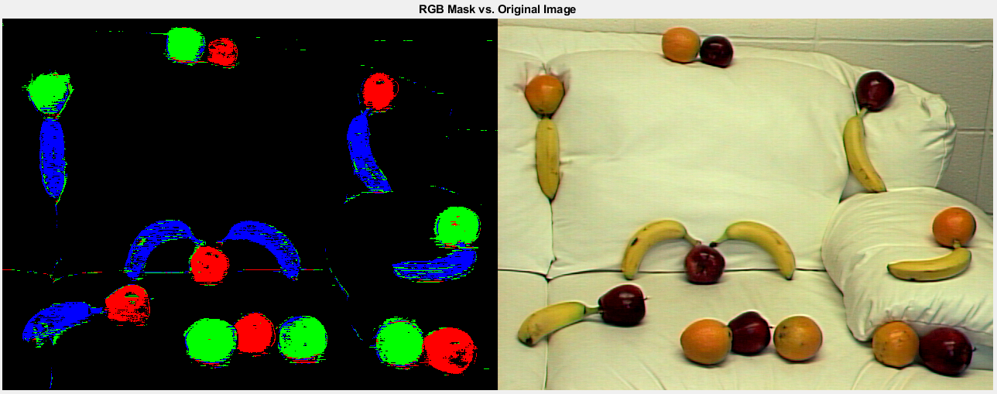

*Figure 14: Left: RGB mask using the final filter values in Table 2. Right: original image, mixed_fruit2.tiff. See additional images and masks in Appendix B.*

Figure 14 shows the performance of the final filter. All the fruit are masked with their respective color aside from a few stray pixels and small clusters. However, these are small enough that they can be removed via post-processing.

**4. POST-Processing**

The fine-tuning of thresholds on the HSV data was not able to give us an accurate mask of the mixed fruit. We do not want small, incorrectly identified clusters of to be counted as fruit. Therefore, we came up with a series of morphological operations to clean up the masks. Prior to performing dilation and erosion, we chose to remove the clusters smaller than 50 pixels. This operation reduces the likelihood that dilation and erosion would create large clusters that would be counted as fruit later.

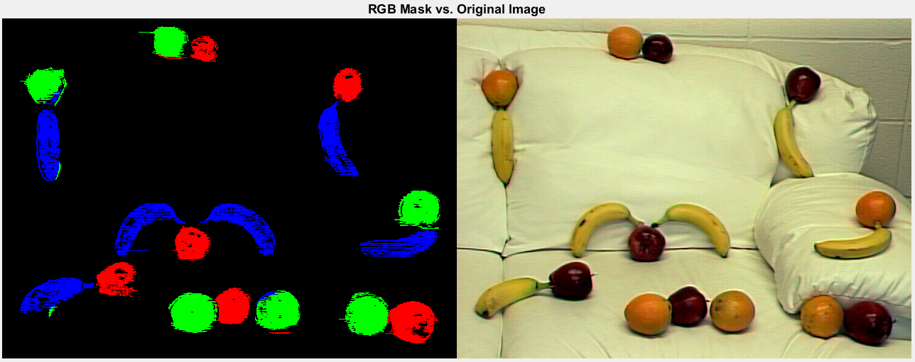

*Figure 15: Left: RGB mask after removing clusters fewer than 50 pixels. Right: original image, mixed_fruit2.tiff. See additional images and masks in Appendix C*

As we can see in Figure 15, the very small pixel clusters were successfully removed. Based on the distance from the object to the camera, the average size of the fruit in the pictures may vary from hundreds of pixels to tens of thousands of pixels. We found the average cluster size of the remaining clusters to approximate the average size of each fruit. We decided to remove the clusters accounting for smaller than one-third of the average size of the object on each picture. This removed clusters that were greater than 50 pixels, but too small to be a fruit.

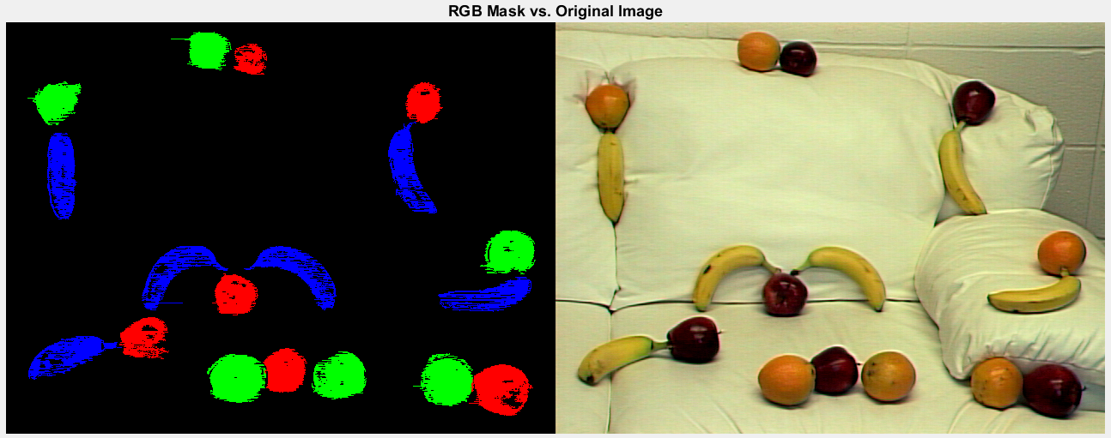

*Figure 16: Left: RGB mask after removing clusters smaller than 1/3 of the average cluster size. Right: original image, mixed_fruit2.tiff. See additional images and masks in Appendix D*

We can see from Figure 16 that some of the larger clusters of pixels that were not an entire fruit were removed. For example, in Figure 15, there was a small cluster of orange right below the bottom-left banana. In Figure 16, this cluster has been removed.

When observing the other two pictures shot from different distances, we noticed that we still needed morphology to fill in the internal holes inside the fruit.

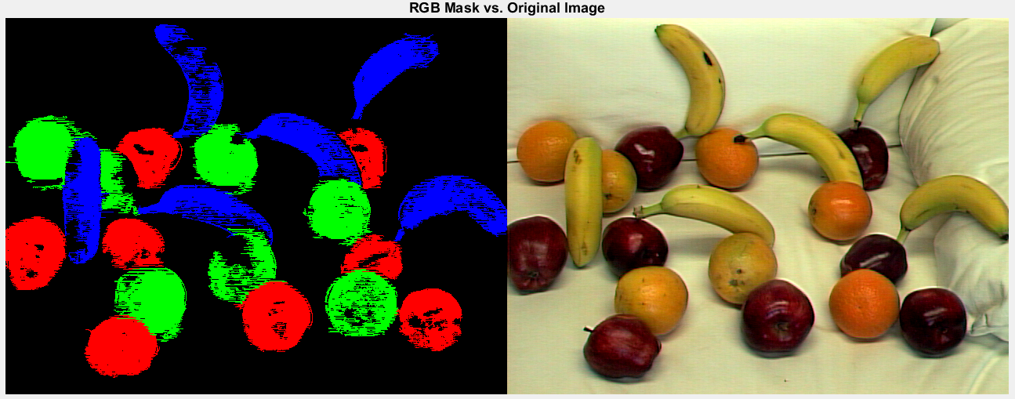

*Figure 17: Left: RGB mask after removing clusters smaller than 1/3 of the average cluster size. Right: original image, mixed_fruit3.tiff.*

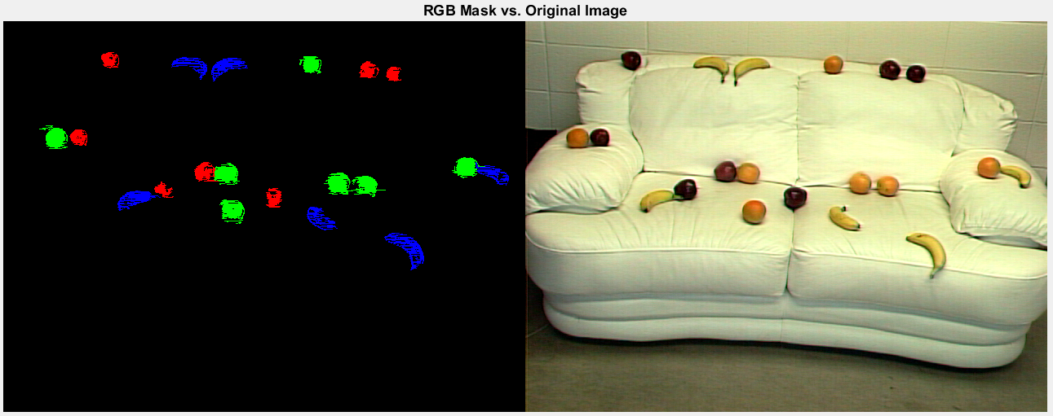

*Figure 18: Left: RGB mask after removing clusters smaller than 1/3 of the average cluster size. Right: original image, mixed_fruit1.tiff.*

Fruit in Figure 17 are full of internal holes, while fruit in Figure 18 have small lines coming from them that need to be removed as well.

To address these issues, we chose to perform a closing then opening operation with an 8-neigborhood structural element on the masks. We chose to close first so that small holes would be closed, and the fruits would be internally connected. We then opened to isolate small fragments that are barely attached to the fruit. An 8-neighborhood structural element worked well to fill small holes without distorting the shape of the fruit. When we tried a 4-neighborhood structural element, it was not large enough to fill the holes.

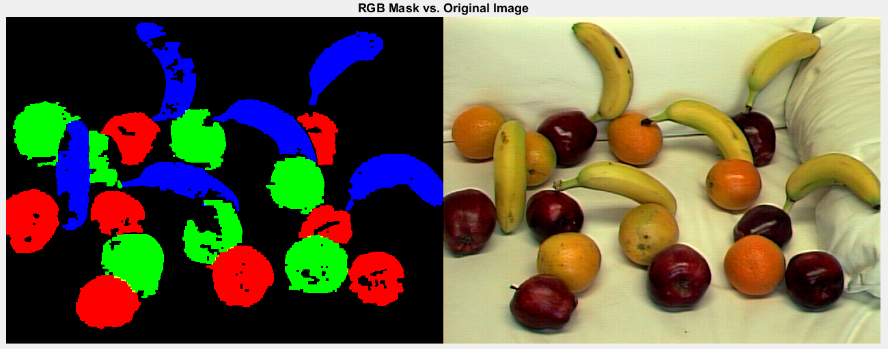

*Figure 19: Left: RGB mask after a closing and an opening. Right: original image, mixed_fruit3.tiff. See additional images and masks in Appendix E.*

The initial closing and opening operations managed to aggregate the fruit and fill some holes, but they were not sufficient. We can see in Figure 19 that there are still a few small clusters of pixels that detached from the fruit when we opened. To remove these small clusters, we chose to remove all clusters smaller than one-fourth of the average cluster size.

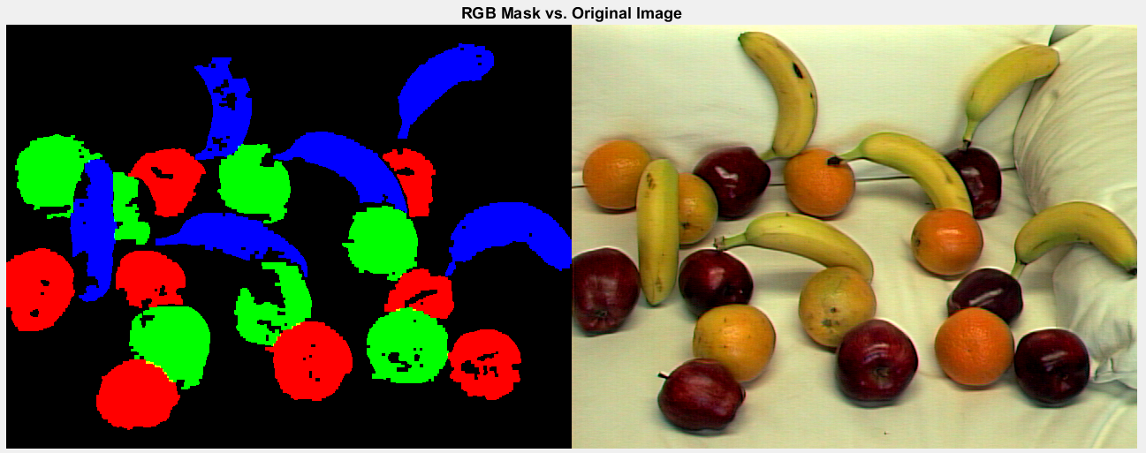

*Figure 20: Left: RGB mask after another removing clusters smaller than ¼ of the average cluster size. Right: original image, mixed_fruit3.tiff. See additional images and masks in Appendix F.*

**5. Results**

Here we will discuss the results of our algorithm. We used a built-in MATLAB function, regionprops, to gather the size and centroid of each fruit.

***Table 3****: This shows the size and centroid of each identified fruit in mixed_fruit1.tiff*

|  |  |  |  |
| --- | --- | --- | --- |
| **Fruit** | **Size** | **Centroid Row** | **Centroid Column** |
| Apple 1 | 343 | 93.606 | 143.41 |
| Apple 2 | 333 | 131.74 | 48.249 |
| Apple 3 | 229 | 196.72 | 208.47 |
| Apple 4 | 444 | 247.12 | 185.58 |
| Apple 5 | 334 | 332.69 | 217.9 |
| Apple 6 | 308 | 447.26 | 60.357 |
| Apple 7 | 239 | 478.68 | 65.126 |
| Orange 1 | 620 | 65.103 | 143.95 |
| Orange 2 | 637 | 274.32 | 188.8 |
| Orange 3 | 640 | 281.81 | 233.02 |
| Orange 4 | 441 | 378.13 | 53.515 |
| Orange 5 | 1201 | 427.18 | 201.16 |
| Orange 6 | 565 | 567.79 | 180.3 |
| Banana 1 | 633 | 161.14 | 218.95 |
| Banana 2 | 540 | 231.82 | 53.931 |
| Banana 3 | 617 | 274.73 | 56.19 |
| Banana 4 | 566 | 388.96 | 244.03 |
| Banana 5 | 911 | 496.5 | 278.42 |
| Banana 6 | 498 | 601.47 | 188.07 |

*Table 4: This shows the size and centroid of each identified fruit in mixed_fruit2.tiff*

|  |  |  |  |
| --- | --- | --- | --- |
| **Fruit** | **Size** | **Centroid Row** | **Centroid Column** |
| Apple 1 | 1892 | 161.1 | 369.41 |
| Apple 2 | 1847 | 267.57 | 319.07 |
| Apple 3 | 1030 | 285.61 | 43.923 |
| Apple 4 | 1993 | 325.67 | 406.96 |
| Apple 5 | 1485 | 486.39 | 94.601 |
| Apple 6 | 2888 | 576.87 | 428.07 |
| Orange 1 | 1902 | 59.955 | 93.38 |
| Orange 2 | 1723 | 236.37 | 33.285 |
| Orange 3 | 3066 | 269.62 | 416.04 |
| Orange 4 | 2691 | 389.18 | 413.86 |
| Orange 5 | 2950 | 513.78 | 418.2 |
| Orange 6 | 2427 | 587.18 | 269.31 |
| Banana 1 | 2572 | 72.874 | 388.83 |
| Banana 2 | 2729 | 65.215 | 178.33 |
| Banana 3 | 2592 | 198.09 | 290.1 |
| Banana 4 | 2806 | 343.99 | 290.9 |
| Banana 5 | 2693 | 468.28 | 175.49 |
| Banana 6 | 2478 | 562.84 | 320.63 |

*Table 5: This shows the size and centroid of each identified fruit in mixed_fruit3.tiff*

|  |  |  |  |
| --- | --- | --- | --- |
| **Fruit** | **Size** | **Centroid Row** | **Centroid Column** |
| Apple 1 | 5691 | 36.995 | 299.33 |
| Apple 2 | 5613 | 148.33 | 420.09 |
| Apple 3 | 3825 | 163.29 | 287.97 |
| Apple 4 | 3962 | 185.75 | 175.45 |
| Apple 5 | 6255 | 345.2 | 381.05 |
| Apple 6 | 2488 | 462.27 | 176.03 |
| Apple 7 | 2796 | 471.88 | 305.62 |
| Apple 8 | 4576 | 543.56 | 384.09 |
| Orange 1 | 5518 | 52.355 | 167.25 |
| Orange 2 | 2182 | 138.43 | 210.75 |
| Orange 3 | 6070 | 189.63 | 360.48 |
| Orange 4 | 5147 | 281.45 | 180.09 |
| Orange 5 | 4376 | 303.94 | 319.94 |
| Orange 6 | 5229 | 426.98 | 246.75 |
| Orange 7 | 6005 | 454.81 | 364.66 |
| Banana 1 | 5513 | 101.81 | 230.15 |
| Banana 2 | 4949 | 257.61 | 241.35 |
| Banana 3 | 4069 | 249.08 | 96.583 |
| Banana 4 | 5492 | 388.99 | 160.12 |
| Banana 5 | 4835 | 492.11 | 63.312 |
| Banana 6 | 6630 | 571.59 | 237.24 |

***Table 6****: This table contains the actual and computed count for each of the fruit in mixed_fruit1.tiff*

|  |  |  |  |
| --- | --- | --- | --- |
| **Fruit** | **Actual** | **Computed** | **Percentage** |
| Apple | 7 | 7 | 100.0% |
| Orange | 7 | 6 | 85.7% |
| Banana | 6 | 6 | 100.0% |
| Total | 20 | 19 | 95.0% |

***Table 7****: This table contains the actual and computed count for each of the fruit in mixed_fruit2.tiff*

|  |  |  |  |
| --- | --- | --- | --- |
| **Fruit** | **Actual** | **Computed** | **Percentage** |
| Apple | 6 | 6 | 100.0% |
| Orange | 6 | 6 | 100.0% |
| Banana | 6 | 6 | 100.0% |
| Total | 18 | 18 | 100.0% |

***Table 8****: This table contains the actual and computed count for each of the fruit in mixed_fruit3.tiff*

|  |  |  |  |
| --- | --- | --- | --- |
| **Fruit** | **Actual** | **Computed** | **Percentage** |
| Apple | 8 | 8 | 100.0% |
| Orange | 7 | 7 | 100.0% |
| Banana | 6 | 6 | 100.0% |
| Total | 21 | 21 | 100.0% |

From Tables 6-8, we can compute that, out of the 59 fruit total, the algorithm found 58 of them, which yields an accuracy of 98.3%. The only error was incorrectly identifying a group of two nearby oranges as a single orange in mixed_fruit1.tiff.

**6. discussion**

**6.1 Performance**

Based on the data in Tables 6-8, we correctly detected 98.3% of the fruit from the three provided test images. There were no false detections. The only error that the algorithm made was that two oranges in mixed_fruit1.tiff were close together and were identified as one orange. This error can be partially attributed to the proximity of the oranges, but also that the oranges are located along an relatively orange shadow on the couch in the background. If this line were not touching the oranges, it might have been removed by our morphological operations. However, since it was part of the orange cluster, it was not removed by these operations. The other way this shadow on the couch could have been removed was further fine-tuning of the h, s, and v thresholds for the oranges. This failure points out that our algorithm does not perform very well with varied backgrounds, particularly from a long distance away. Decreasing the size of the fruit makes it harder to distinguish colorful background noise from fruit.

While the high percentage of fruit detected may indicate that our algorithm performed very well, the resulting masks are not perfect. Many of the fruits have blemishes or color variations that our algorithm does not recognize. For example, several of the apples and oranges have reflections that were not considered to be part of the fruit by the algorithm. We attempted to fill in these regions of the mask with morphology, but we could not completely fill them while maintaining the correct shape of the fruit.

**6.2 Fruit Tray**

We also tried to apply our model to the fruit_tray.tiff image. Since there are many overlapping fruit of the same type, our algorithm struggles to identify individual fruits. The algorithm cannot detect the edges but only the color space and histogram differences. For bananas and oranges, it only identifies one large blob. However, the algorithm was able to count a few apples. This is because the dark spaces around each apple was below the value threshold. Even so, the count was not correct.

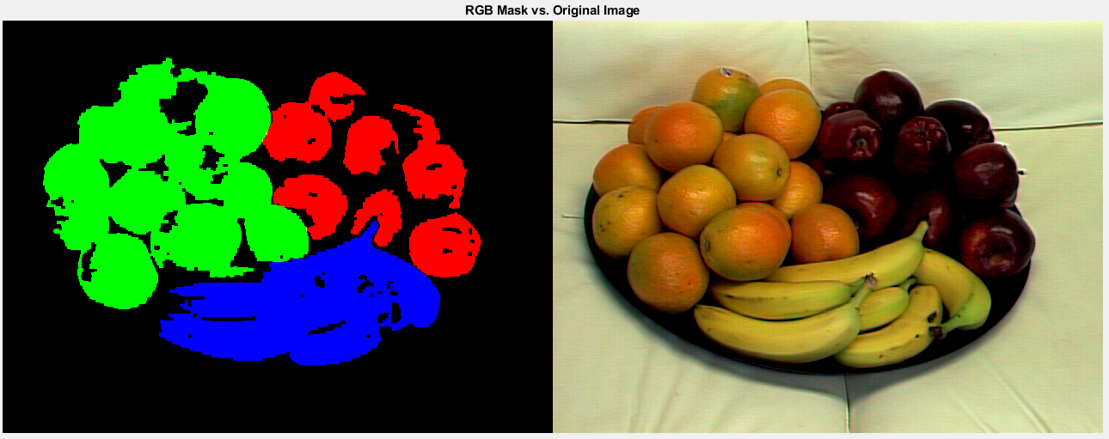

*Figure 21: Left: This shows the rgb mask produced by the completed algorithm. Right: This shows the original fruit_tray.tiff image.*

*Table 9: This shows the size and centroid of each identified fruit in fruit_tray.tiff*

|  |  |  |  |
| --- | --- | --- | --- |
| **Fruit** | **Size** | **Centroid Row** | **Centroid Column** |
| Apple 1 | 6361 | 358.16 | 117.05 |
| Apple 2 | 3812 | 363.44 | 211.7 |
| Apple 3 | 3056 | 426.01 | 144.58 |
| Apple 4 | 2242 | 440.02 | 228.07 |
| Apple 5 | 4769 | 500.4 | 166.59 |
| Apple 6 | 4635 | 514.35 | 263.71 |
| Orange 1 | 51191 | 194.14 | 193.87 |
| Banana 1 | 29365 | 354.16 | 334.43 |

*Table 10: This table contains the actual and computed count for each of the fruit in mixed_tray.tiff*

|  |  |  |  |
| --- | --- | --- | --- |
| **Fruit** | **Actual** | **Computed** | **Percentage** |
| Apple | 10 | 6 | 60.0% |
| Orange | 15 | 1 | 6.7% |
| Banana | 6 | 1 | 16.7% |
| Total | 31 | 8 | 25.8% |

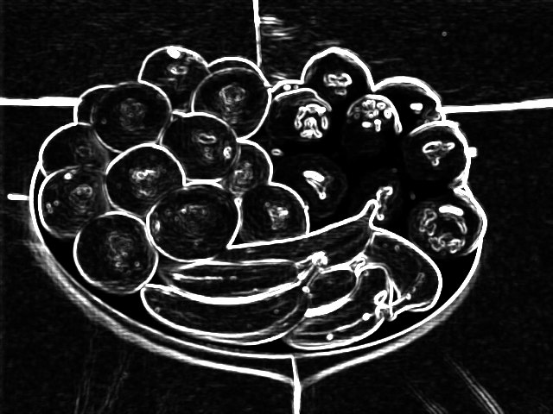

*Figure 22: This shows the result of applying a variance filter to the grayscale image of fruit_tray.tiff.*

The results shown in Figure 22 and Table 9 show that our color thresholds and morphology alone are not sufficient for identifying specific fruit within piles. However, when we apply a variance filter on the image for the edge detector, we can see from Figure 23 that oranges and bananas can be distinguished better, while the apples cannot be easily counted. The apples are too dark around the edges for a prominent edge to be seen using the edge detector. It seems that some combination of edge detection and color thresholds would be needed to count all the fruit in the piles.

**6.3 Future Plan**

Our algorithm could be improved significantly through the use of an edge detector. From the edge detection, we could find information about the shape of a formation. Shape coupled with color characteristics could make it easier to classify fruit. Additionally, it would make filling a shape easier. We would have the boundaries of an entire fruit, so we could simply fill in all of the pixels in the mask that fall inside the detected edge of the fruit. This would solve the problem of the apple reflections or banana bruises. It would be ideal to reject the background using color thresholds prior to using edge detection to avoid finding unrelated edges in the background.

In the long term, to improve our fruit finder, we would want to gather a very large sample of fruit images and feed these to a machine learning algorithm so that it can determine a precise set of classifiers. Once it has these classifiers, identifying fruit in new images should be much more accurate.

**7. conclusions**

Our study on finding fruit showed that using color thresholds and morphology alone is not sufficient for classifying images. Even with simple backgrounds, our algorithm was unable to distinguish every fruit. Additional information such as edge features and shape may be needed to create a more complete fruit finding algorithm.

### Appendix A

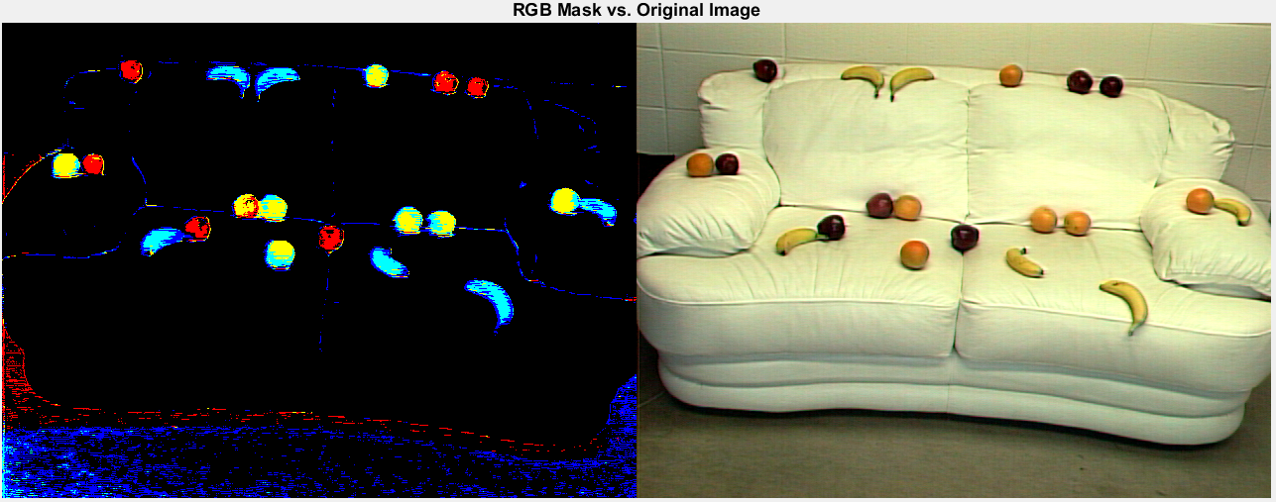

*Figure A.1: Left: RGB mask using the initial filter values in Table 1. Right: original image, mixed_fruit1.tiff.*

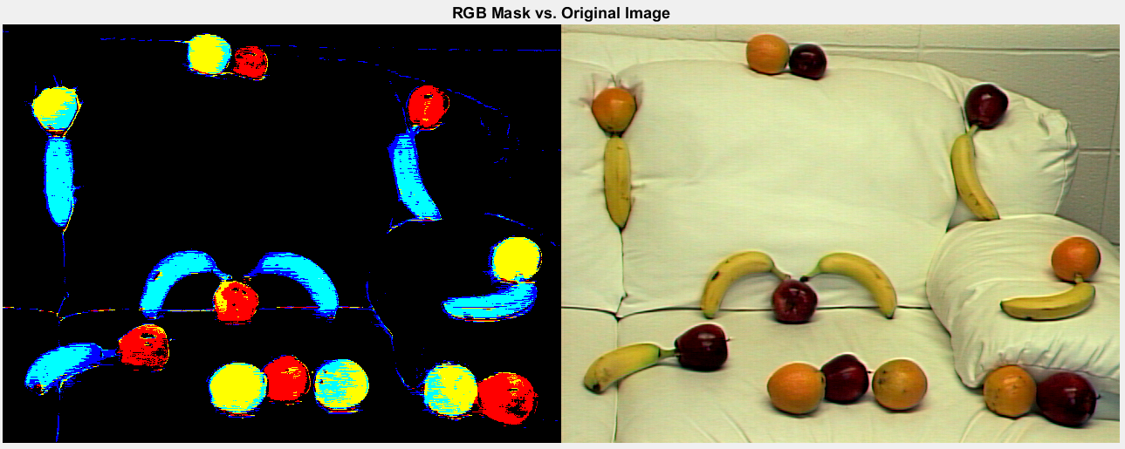

*Figure A.2: Left: RGB mask using the initial filter values in Table 1. Right: original image, mixed_fruit2.tiff.*

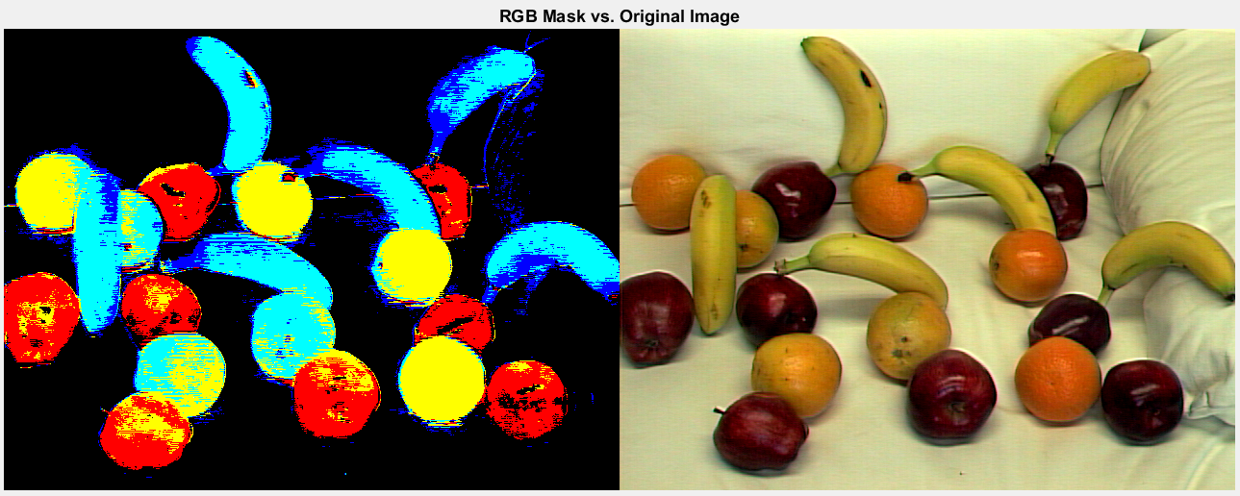

*Figure A.3: Left: RGB mask using the initial filter values in Table 1. Right: original image, mixed_fruit3.tiff.*

### Appendix B

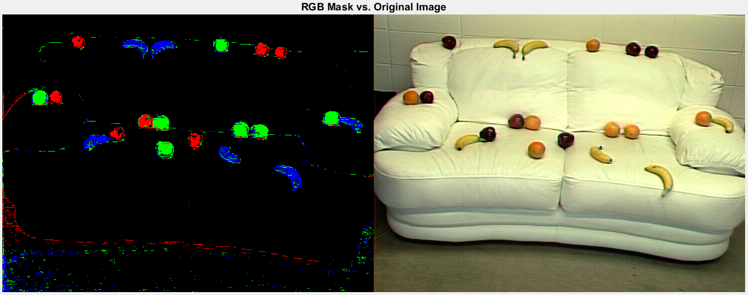

*Figure B.1: Left: RGB mask using the final filter values in Table 2. Right: original image, mixed_fruit1.tiff.*

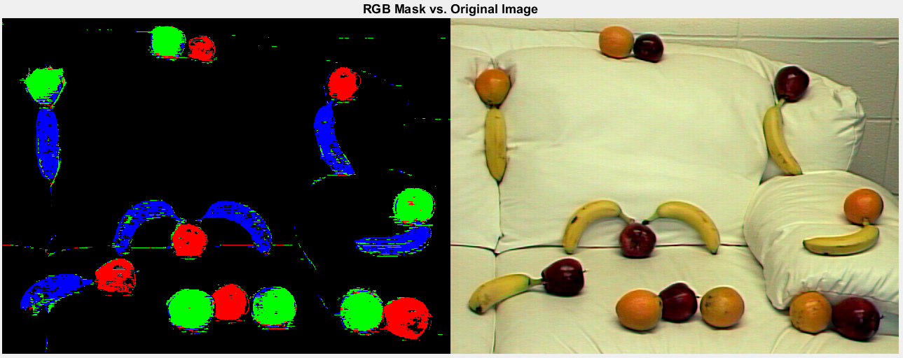

*Figure B.2: Left: RGB mask using the final filter values in Table 2. Right: original image, mixed_fruit2.tiff.*

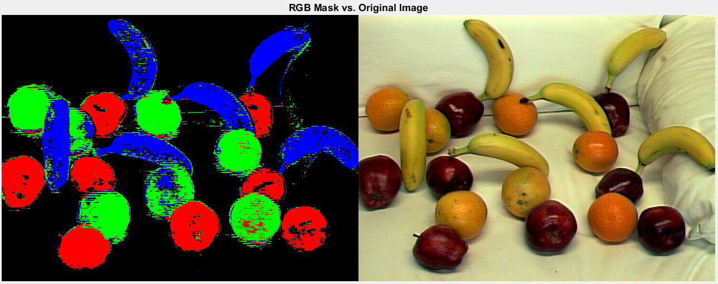

*Figure B.3: Left: RGB mask using the final filter values in Table 2. Right: original image, mixed_fruit3.tiff.*

**Appendix C**

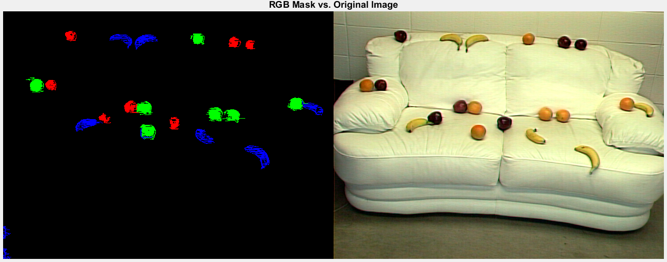

*Figure C.1: Left: RGB mask after removing clusters fewer than 50 pixels. Right: original image, mixed_fruit1.tiff*



*Figure C.2: Left: RGB mask after removing clusters fewer than 50 pixels. Right: original image, mixed_fruit2.tiff*

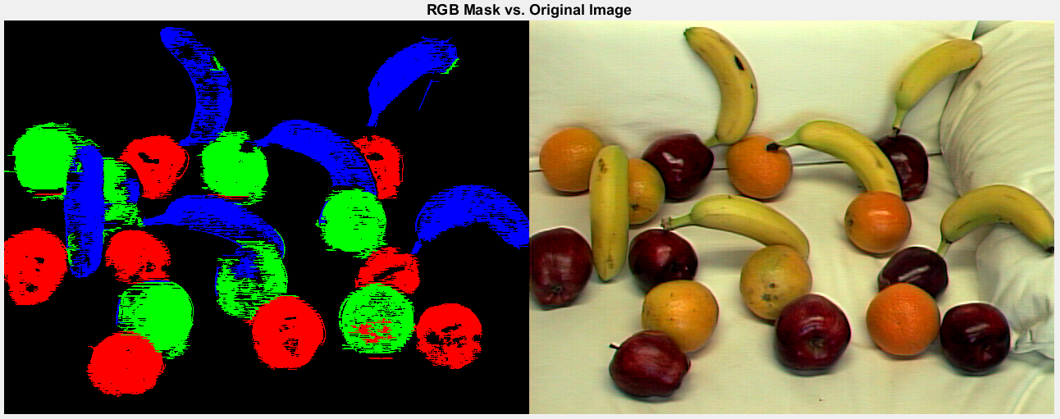

*Figure C.3: Left: RGB mask after removing clusters fewer than 50 pixels. Right: original image, mixed_fruit3.tiff*

**Appendix D**



***Figure D.1****: Left: RGB mask after removing clusters smaller than 1/3 of the average cluster size. Right: original image, mixed_fruit1.tiff.*



***Figure D.2****: Left: RGB mask after removing clusters smaller than 1/3 of the average cluster size. Right: original image, mixed_fruit2.tiff.*



***Figure D.3****: Left: RGB mask after removing clusters smaller than 1/3 of the average cluster size. Right: original image, mixed_fruit3.tiff.*

**Appendix E**

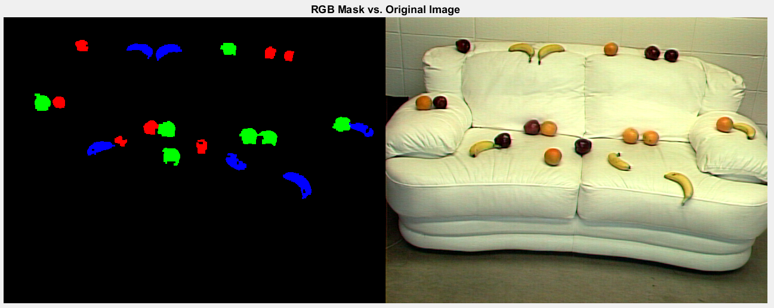

***Figure E.1****: Left: RGB mask after closing and opening with a 3x3 structural element. Right: original image, mixed_fruit1.tiff.*

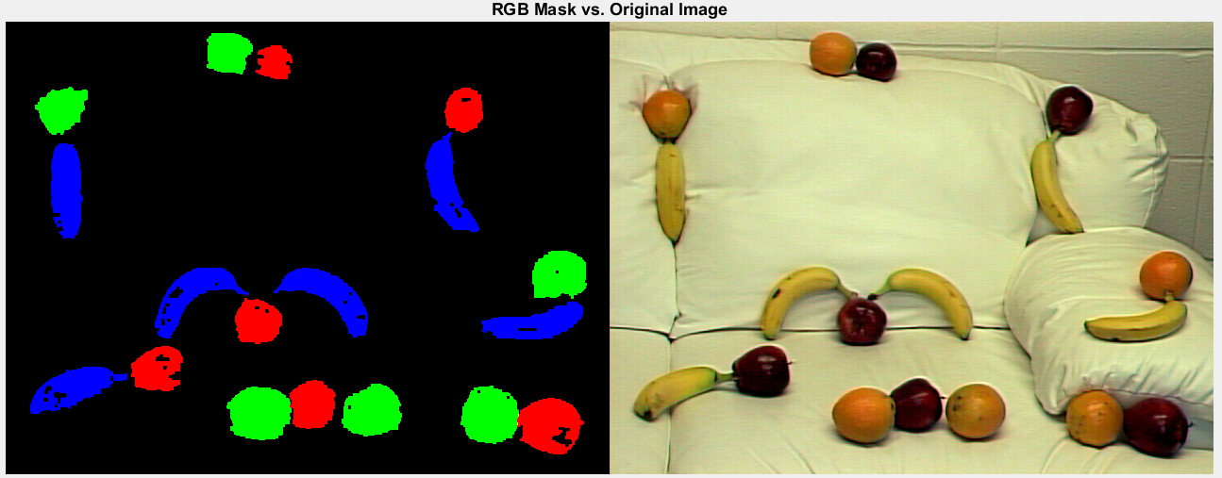

***Figure E.2****: Left: RGB mask after closing and opening with a 3x3 structural element. Right: original image, mixed_fruit2.tiff.*



***Figure E.3****: Left: RGB mask after closing and opening with a 3x3 structural element. Right: original image, mixed_fruit3.tiff.*

**Appendix F**

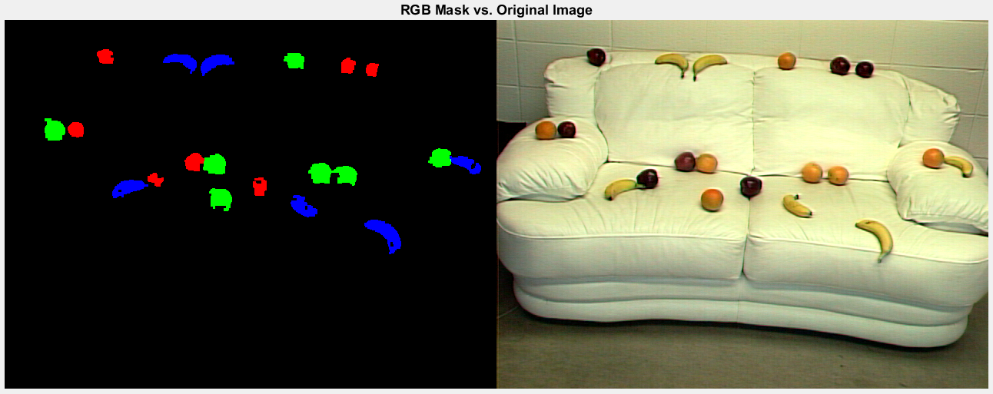

***Figure F.1****: Left: Final RGB mask. Right: original image, mixed_fruit1.tiff.*

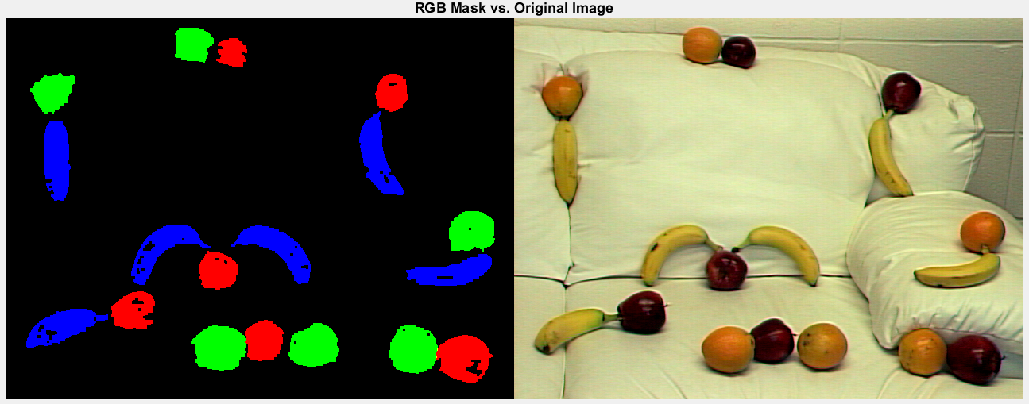

***Figure F.2****: Left: Final RGB mask. Right: original image, mixed_fruit2.tiff.*



***Figure F.3****: Left: Final RGB mask. Right: original image, mixed_fruit3.tiff.*